Part 1 – Problem Framing
Real business problem
Win rate has become unreliable over recent months, even though the number and value of opportunities look healthy; the CRO needs to know where the funnel is breaking and which levers will actually lift win rate and revenue, not just see more reports.
Key questions for the AI system
- In which segments (time, industry, region, product, lead_source, value band) is win rate dropping most?
- At which stages is the funnel leaking (stage‑to‑stage conversion and per‑stage win rate)?
- Which reps, segments, and lead sources consistently over‑ or under‑perform?
- What early signals (age, stage, segment, source) indicate that an open deal is at high risk of loss?
Core diagnostic metrics
- Win rate by month/quarter of closed_date.
- Win rate by industry, region, product_type, lead_source, stage, and value band.
- Stage‑to‑stage conversion and per‑stage win rate.
- Sales_cycle_days by outcome and segment.
Key assumptions
- CRM fields are reliable and consistently defined across time.
- Outcome (Won/Lost) is complete for the historical deals analyzed.
- Sales stages and process have not changed materially in the observed period.
- External factors (macro, competitors) are not explicitly modeled; we focus on the internal sales dataset.

Part 2 – Exploratory Data Analysis (EDA)
This section explores the SkyGeni sales dataset to understand why win rate has dropped despite a healthy pipeline and to surface actionable insights for the CRO.​
We:
- Quantify overall performance and baseline win rate.​
- Analyze how win rate varies by industry, region, lead source, and stage.​
- Define two custom metrics that go beyond simple overall win rate.​
- Translate findings into plain business language with concrete actions.​

Overall performance and baseline

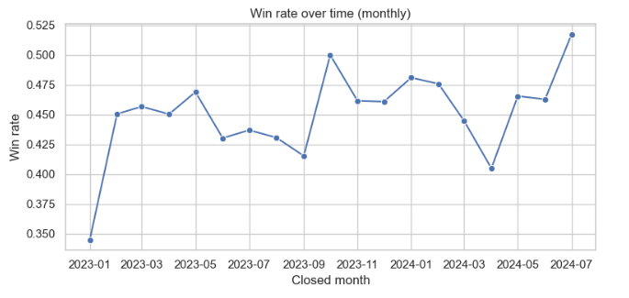
- Overall win rate is about 45%, based on a balanced mix of Won and Lost deals across 5k opportunities.​
- Deal amounts are highly skewed (median ≈ 14k, 75th percentile ≈ 39k, max 100k), and sales cycles range widely (median ≈ 64 days, 75th percentile ≈ 92 days).​
Why it matters
- This baseline win rate is the anchor to judge whether specific segments (industries, regions, lead sources, stages) are over‑ or under‑performing.​
- The skew in deal size and sales cycle means a small number of large, long‑running deals can disproportionately impact bookings and perceived performance.​

Possible actions
- Use the 45% baseline as the reference when setting targets or prioritizing improvement initiatives.​
- Monitor large, long‑cycle deals separately with more structured deal reviews, since they represent outsized risk and upside.​

Custom Metric 1 – Monthly win rate trend
We define a custom metric: win rate by closed month, i.e., share of Won deals among all deals closed in each calendar month.​
- Monthly win rate fluctuates around the 45% baseline, with some recent months dipping below and others recovering above 50%.​
Why it matters
- Directly addresses the CRO’s concern that “win rate has dropped” by showing if the decline is persistent or a short‑term blip.​
- Helps tie performance changes to specific time windows (e.g., after new pricing, playbooks, or territory changes).​
Possible actions
- If the last 2–3 months sit noticeably below baseline, investigate what changed in that period: ICP targeting, discounting, comp plans, process or staffing.​
- If a recovery is visible, treat the earlier dip as a learning opportunity and codify what is now working into playbooks.​

Custom Metric 2 – High‑value win rate
We define “high‑value deals” as the top 25% of opportunities by ACV (deal amount) and compute a separate win rate for these deals.​
- High‑value deals have a win rate of about 46.4%, slightly above non‑high‑value deals at about 44.9%.​
Why it matters
- CROs care more about total revenue than raw count of wins; losing a few large deals can hurt bookings even if headline win rate looks flat.​
- A healthy or improving high‑value win rate indicates the team is protecting strategic revenue, even if overall win rate is noisy.​

Possible actions
- If high‑value win rate weakens, assign senior reps or dedicated deal coaches to large opportunities, and bring leadership into key milestones earlier.​
- Track this metric separately in QBRs and tie enablement/coaching plans specifically to big‑deal performance.​

Insight – Industry‑level win rate differences
We compute win rate and deal volume by industry.​
- Some industries show win rates comfortably above baseline with good volume, while others lag despite similar or higher volume.​
Why it matters
- High‑win‑rate industries are “sweet‑spot” segments where product–market fit and messaging are strong; these are the safest bets for near‑term growth.​
- Persistently low win rate in a segment suggests poor fit, mis‑targeting, or weak value narrative.​
Possible actions
- Double down on high‑win‑rate industries with more marketing spend, SDR capacity, and named‑account focus.​
- In low‑win‑rate industries, either reposition (new messaging, packaging) or deliberately deprioritize them in ICP definitions.​

Insight – Regional performance patterns
We compute win rate and deal volume by region.​
- Regions have broadly similar win rates (all close to baseline), but small differences indicate some territories convert slightly better than others at similar volumes.​
Why it matters
- Highlights where GTM execution, local competition, or territory design are helping or hurting.​
- Gives the CRO a data‑driven basis for rebalancing headcount and quota across regions.​
Possible actions
- Shift pipeline coverage, marketing budgets, or enablement attention from weaker regions to stronger ones to maximize return on effort.​
- In under‑performing regions, audit qualification quality, local competitive dynamics, and region‑specific objections, then adjust playbooks accordingly.​

Insight – Stage‑level conversion behavior
We analyze win rate by current stage (Qualified, Demo, Proposal, Negotiation, Closed).​
- Some stages (e.g., early qualification) convert well, while later stages like Proposal or Negotiation show lower win rates and many eventual losses.​
Why it matters
- Identifies “leaky” stages where many deals stall or die; this is where targeted enablement delivers the highest ROI.​
- Shows whether the problem is top‑of‑funnel (bad fit deals entering) or late‑stage (pricing, competitive pressure, lack of champions).​
Possible actions
- For low‑conversion stages, introduce stage‑specific objection‑handling scripts, pricing guardrails, and mandatory deal reviews.​
- If a stage has very high volume but low win rate, tighten entry criteria so only truly qualified deals progress.

Part 3 – Win Rate Driver Analysis (Decision Engine)

1. Problem definition
For Part 3, I selected Option B – Win Rate Driver Analysis.​
The goal is to identify which factors (industry, region, lead source, deal stage, deal size, sales cycle) are associated with higher or lower win rate, and to build a simple decision engine that sales leaders can use to prioritize segments and deals.​
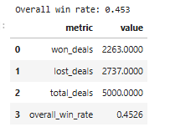

2. Model / rule‑based approach
Instead of a black‑box ML model, I treat win rate as a segment property and use simple, interpretable rules.​

2.1 Features
- Target: won_flag (1 if Won, 0 otherwise).​
- Numeric: log_dealamount (log of deal_amount), salescycle_bin (quartile of sales_cycle_days).​
- Categorical: industry, region, lead_source, deal_stage.​

2.2 Single‑dimension drivers
I compute win rate by industry, region, lead source, and deal stage using simple group‑bys.​
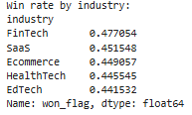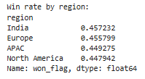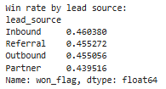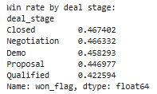
From these tables we see, for example, that FinTech and some lead sources (Inbound/Referral) are above the global win rate, while the Qualified stage is comparatively leaky.​

2.3 Multi‑dimensional driver table
Next, I build a driver table on 3‑way segments (industry, region, lead_source).​
For each segment I compute:
- deals – number of deals in the segment.​
- win_rate – mean of won_flag.​
- avg_amount – average deal_amount.​
- lift_vs_baseline – win_rate − overall_win_rate.​
- driver_score – win_rate × avg_amount, a simple proxy for expected revenue quality.​
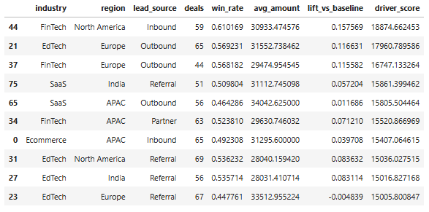
These rows highlight the strongest driver segments, e.g., FinTech / North America / Inbound with high win rate, strong lift vs baseline, and high average deal amount.​

2.4 Stage‑aware probabilities and risk bands
To make the engine usable at the deal level, I compute stage‑aware segment win rates on (industry, region, lead_source, deal_stage) and join them back to each deal as seg_win_prob.​
I then map seg_win_prob into simple risk bands:​
- seg_win_prob ≥ 0.6 → low_risk_high_fit
- 0.45 ≤ seg_win_prob < 0.6 → medium_risk
- seg_win_prob < 0.45 → high_risk
- Missing → unknown​
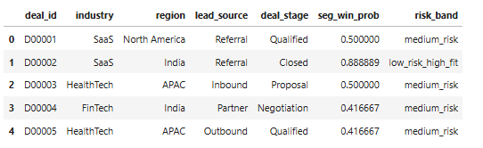
This turns historical segment performance into a straightforward, rule‑based deal score.​

3. Key charts to support the engine
To make the drivers easy to interpret visually, I include two charts based on the driver table.​
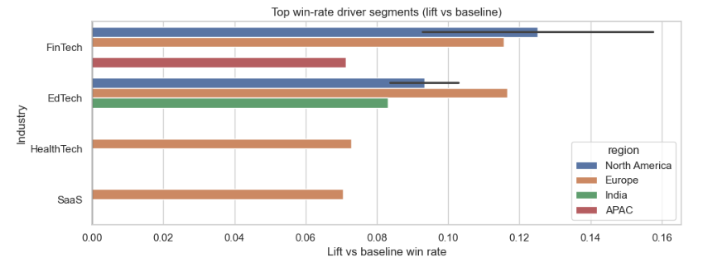
This chart highlights segments where win rate is significantly above the baseline, by industry and region.​
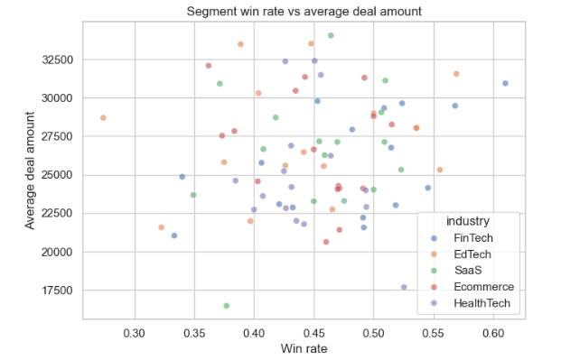
Segments in the top‑right (high win rate, high deal amount) are the most attractive targets for pipeline focus.​

4. How a sales leader would use this
- Forecast quality:
Review pipeline distribution by risk_band and by top driver segments to see whether the forecast is concentrated in strong or weak areas.​
- Prioritization and coaching:
Use seg_win_prob and risk_band to focus coaching and senior support on high‑risk, high‑value deals instead of treating all deals equally.​
- ICP / GTM design:
Use the driver table and charts to refine ideal customer profile, territories, and marketing spend toward segments with high win rate and high driver_score.​
- Playbook tuning:
For segments or stages with low win rate, tighten qualification, adjust messaging, or add stage‑specific reviews.​
This approach uses simple, interpretable rules rather than complex models, matching the brief’s emphasis on reasonable modeling choices, clear interpretation, and practical business usefulness.

Part 4 – Mini System Design: Sales Insight & Alert System

High-level architecture
The Sales Insight & Alert System has four main components.​
- Data sources
  - CRM / sales platform: deals, stages, reps, amounts, outcomes.​
  - Analytics store / warehouse where historical deals are loaded daily.​
- Ingestion & storage
  - A scheduled ETL job loads updated deals into a central sales analytics table (like your df view with won_flag).​
  - Baseline metrics (e.g., overall win rate ≈ 0.453) are recomputed each run.​

- Insight engine
Batch job compute
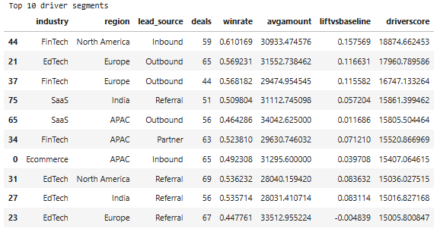
Segment driver table (industry, region, lead_source) with deals, winrate, avgamount, liftvsbaseline, driverscore.​
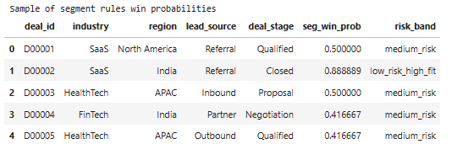
Stage-aware segment win probabilities and risk bands per deal.​
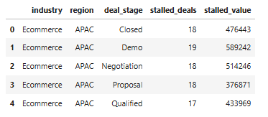
Stalled pipeline summary by (industry, region, deal_stage) with stalled_deals and stalled_value.​
.​
- Alert & delivery layer
  - A light service or scheduled script converts these insights into structured alerts:
    - High‑performing segments from the driver table.​
    - Stalled pipeline pockets.​
    - High‑risk, high‑value deals for coaching.​
  - Alerts are written to an alerts table (or JSON) and surfaced via:
    - Email / Slack digest for leaders.
    - A simple dashboard for filtering by alert type, severity, region, or owner.

Data flow
End‑to‑end flow in batch mode:​
- Extract from CRM → raw deals in warehouse.
- Transform in the insight job:
  - Compute won_flag, segment driver stats, seg_win_prob, risk_band, stalled flags.​
- Load into:
  - segment_drivers (your driversorted).​
  - deal_insights (columns like seg_win_prob, risk_band).​
  - stalled_summary table.​
- Alerting job reads these tables, builds alert messages, and sends/publishes them.​

Example alerts and insights
Using your computed tables, typical alerts could be:
- High‑performing segment alert
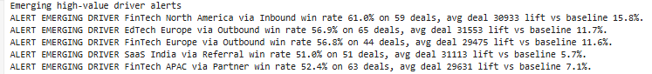
“FinTech / North America / Inbound shows win rate 15–16 p.p. above baseline (≈0.61 vs 0.45) with high average deal amount. Prioritize pipeline and marketing in this segment.”

- Stalled pipeline alert
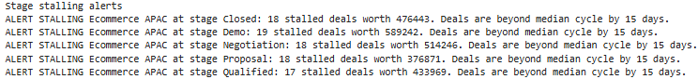
“Ecommerce / APAC / Demo has 19 stalled deals worth ~$589k. Review in this week’s pipeline meeting.”
- High‑risk, high‑value deal alert
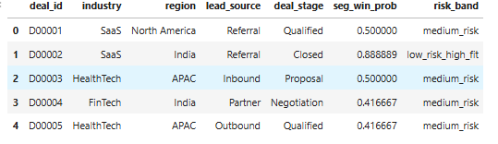
“Deal D00005 (HealthTech / APAC / Outbound, stage Qualified) is high‑value but has segment win prob ~0.42 and high_risk band. Recommend manager + AE review.”
These alerts are generated from the same logic used to build driverscore, seg_win_prob, and stalled metrics; the system just packages them into human‑readable messages.

How often it runs
A realistic schedule:​
- Insight engine (metrics + summaries): run daily (overnight) so every morning’s alert reflects fresh data.
- Alert generation: run immediately after insights, also daily; optionally a weekly summary for leadership.​
This fits easily into a lightweight Airflow / cron / cloud‑scheduler job.

Failure cases and limitations
Key limitations for this v1 system:​
- Data quality: wrong stages, missing dates, or incorrect outcomes will distort win rates, risk bands, and stalled flags.​
- Sparse segments: segments with few deals produce noisy winrate and seg_win_prob; alerts on those should be down‑weighted or suppressed.​
- Changes in GTM: if pricing, ICP, or strategy change, historical segment performance may no longer predict future behavior.​
- Rule simplicity: this design intentionally uses simple thresholds and segment stats; it should complement, not replace, more advanced modeling and human judgment.​
Even with these constraints, this architecture is lightweight, explainable, and easy to productize as a first version of the SkyGeni Sales Insight & Alert System.

Part 5 – Reflection

5.1 Weakest assumptions
The weakest assumption is that past win‑rate patterns by simple CRM fields (industry, region, lead_source, deal_stage) will remain stable and predictive over time. In reality, sales strategy, product positioning, competition, and macro conditions can shift quickly and make historical segment win rates less relevant.
I also assume the synthetic dataset is reasonably representative of a real B2B SaaS pipeline, even though it has clean fields, consistent stages, and no missing or messy data. This makes it easier to build a tidy decision engine, but it hides many practical data quality issues that a production SkyGeni system would have to handle.

5.2 What would break in production
In real‑world production, the first thing that would break is data quality and schema stability. If the CRM fields change (new stages, renamed lead sources, missing closed_dates, inconsistent outcomes), the current grouping and alert logic could silently produce misleading or empty outputs.
The batch alert rules also assume stable volumes per segment and enough data to compute reliable win rates. In a smaller customer, some segments will be very sparse, so the system might fire noisy alerts or miss emerging issues where sample sizes are tiny. Finally, there is no user management, access control, or integration layer—today it lives in notebooks, not in a robust service that can be monitored and versioned.

5.3 What I would build next (1 month)
With one month, I would focus on three concrete extensions:
- Harden the data layer: add validation checks, minimum volume rules, and fallbacks when segments are too small or fields are missing, plus basic monitoring for pipeline freshness.
- Build a simple service + dashboard: productionize the core aggregations and alert rules into a scheduled job (for example, a Python service or SQL/dbt pipeline) and surface results in a minimal dashboard or embedded in CRM.​
- Add smarter prioritization and feedback: let sales leaders up‑vote or down‑vote alerts, track which alerts led to actions, and use this feedback to adjust thresholds or highlight the most impactful patterns over time.​
These steps keep the system simple but move it closer to a product that a CRO can rely on every week, not just a one‑off analysis.

5.4 Least confidence
I am least confident about the alert thresholds and banding choices. For example, the 8‑point win‑rate drop threshold, 40% low‑fit pipeline share, and 15‑day stalling margin are hand‑picked and tuned to this dataset rather than calibrated with real user feedback.
I am also cautious about the risk bands (low/medium/high fit) because they compress continuous probabilities into coarse labels. In practice, these bands should be validated with sales leaders on real deals and possibly augmented with more features (rep behavior, competition, deal size buckets) before being used for important decisions like forecast adjustments or performance reviews.

